COMPUTER NETWORKS –CSA0763

NAME : N DIVAKAR

REG NO : 192211362

EXPERIMENT 1

1. Configuration of Network Devices using Packet Tracer (Hub, Switch, Ethernet, Broadcast)

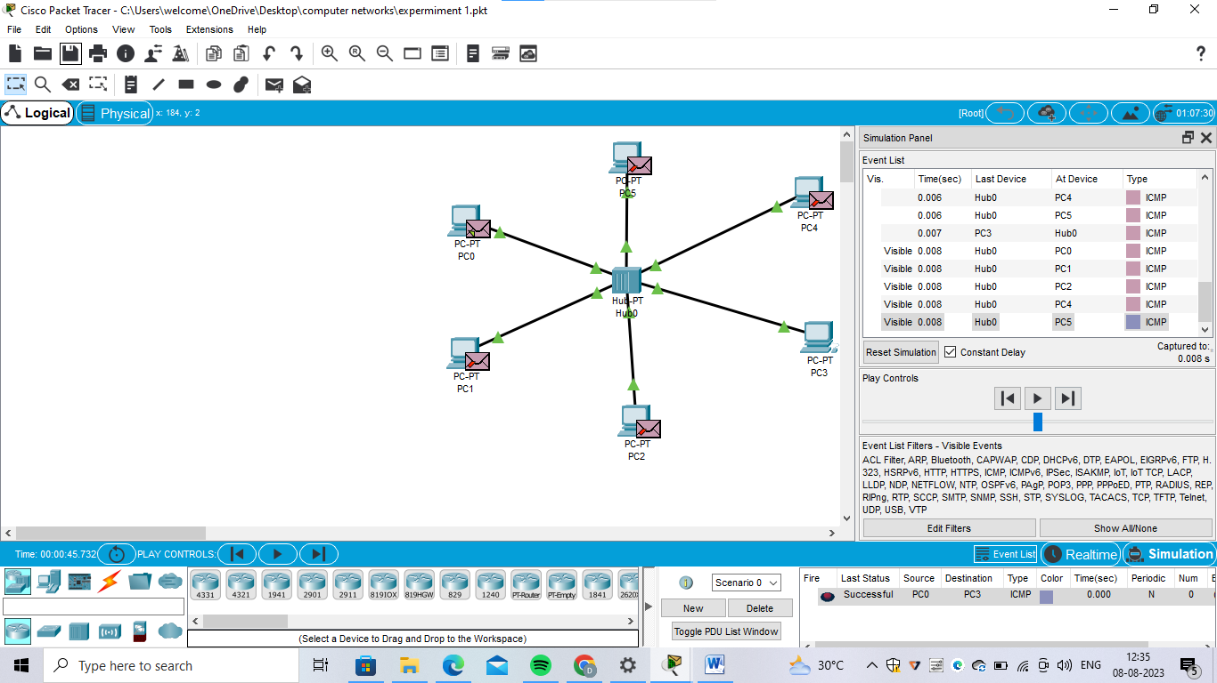

1. Configuration of Topologies using Packet Tracer (Star, Mesh, Tree,)

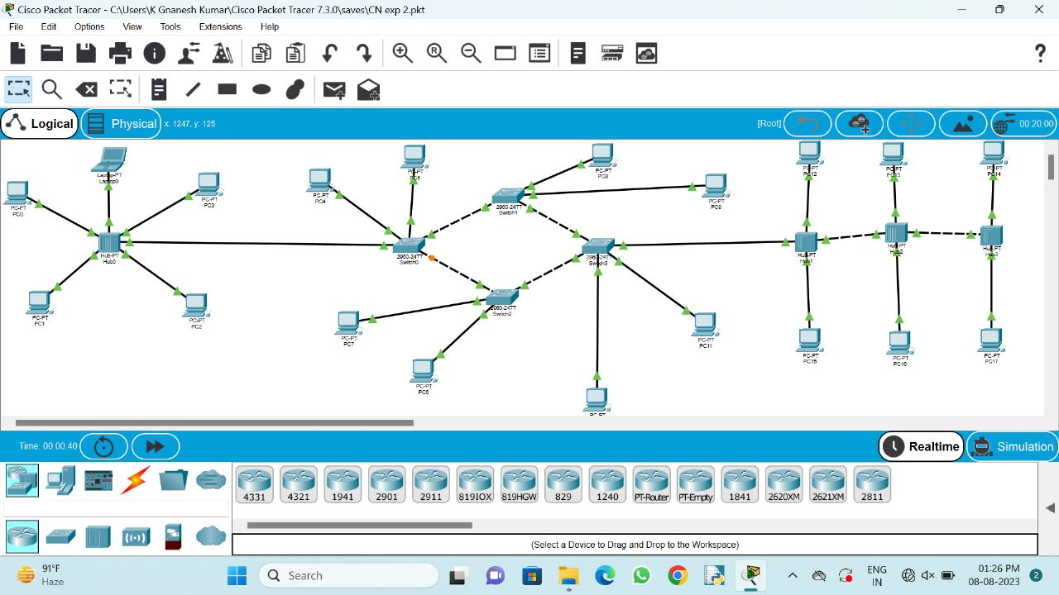

1. Configuration of Topologies using Packet Tracer (Bus, Ring, Hybrid)

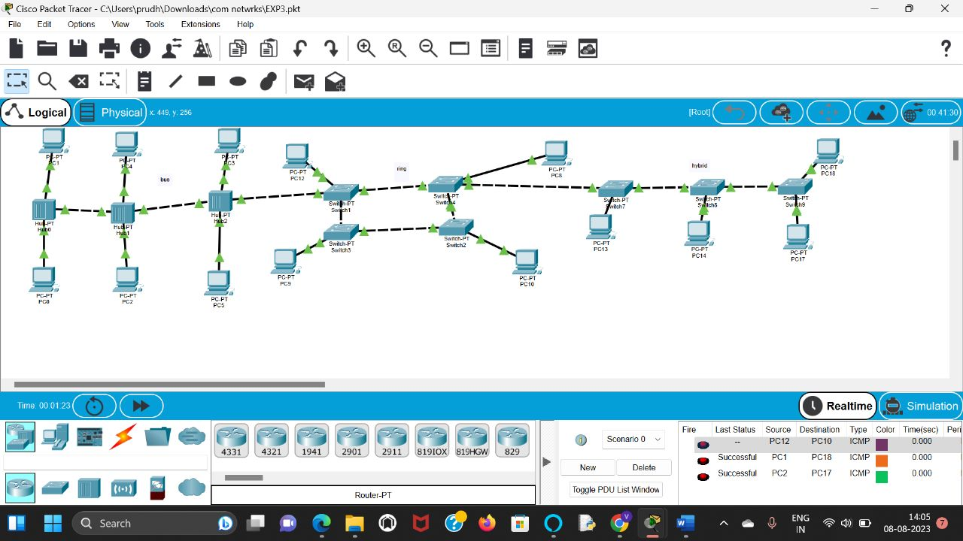

1. Data Link Layer Traffic Simulation using Packet Tracer Analysis of CSMA/CD& CSMA/CA

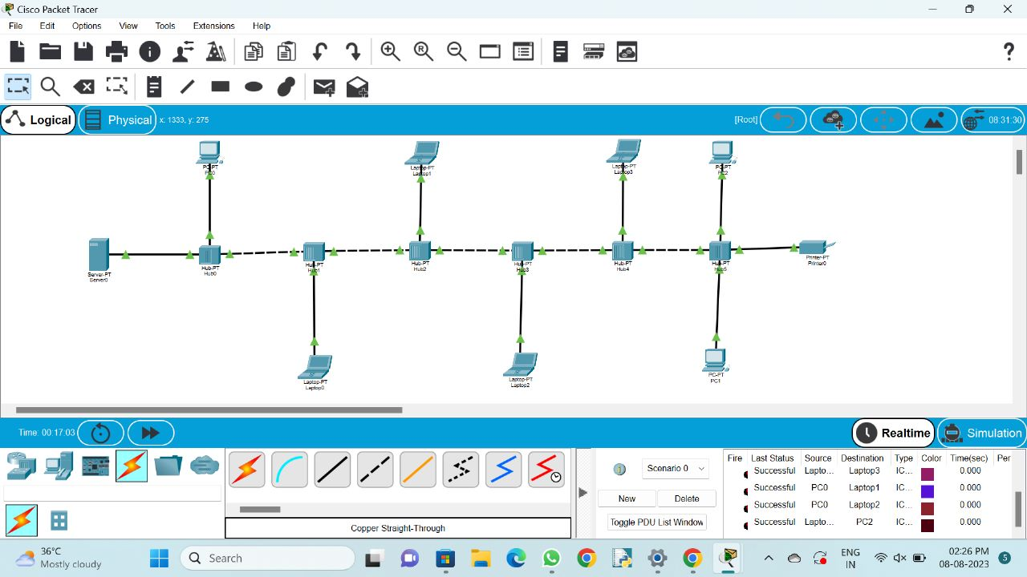

1. Data Link Layer Traffic Simulation using Packet Tracer Analysis of ARP

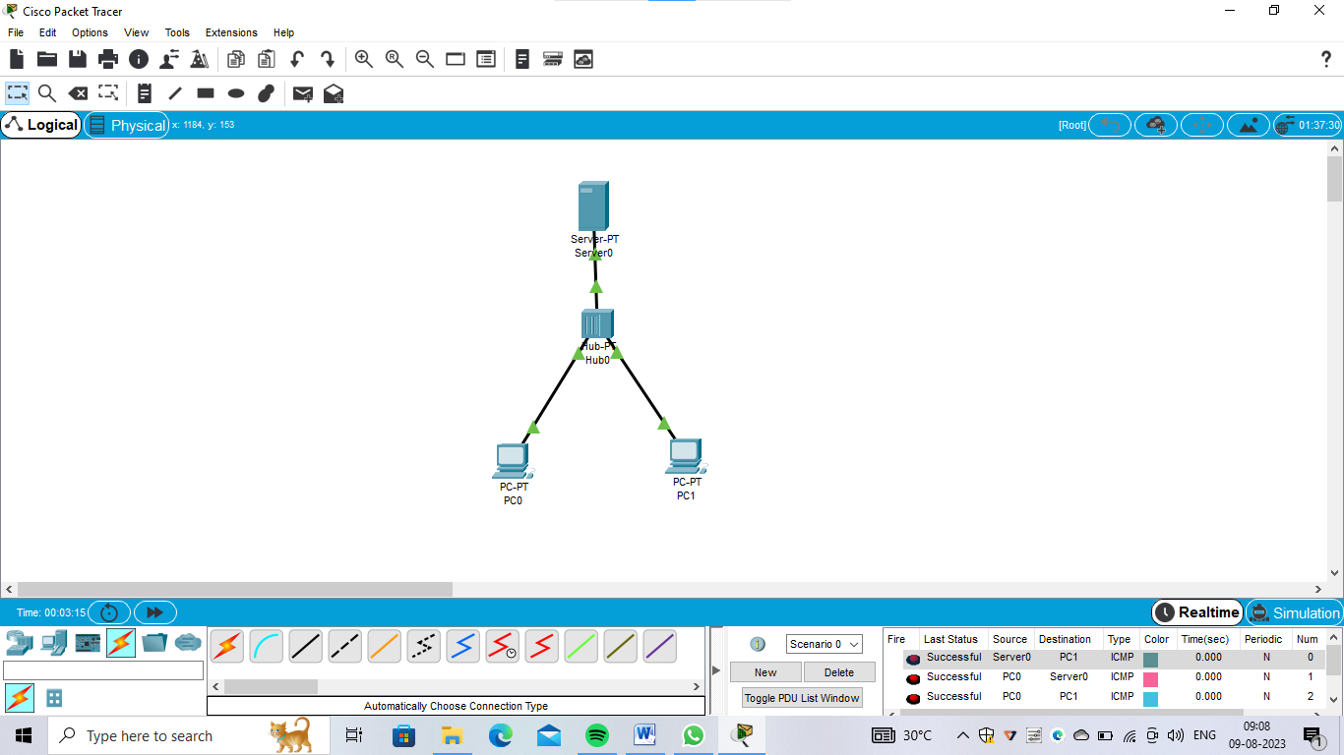

1. Static Routing using Packet Tracer

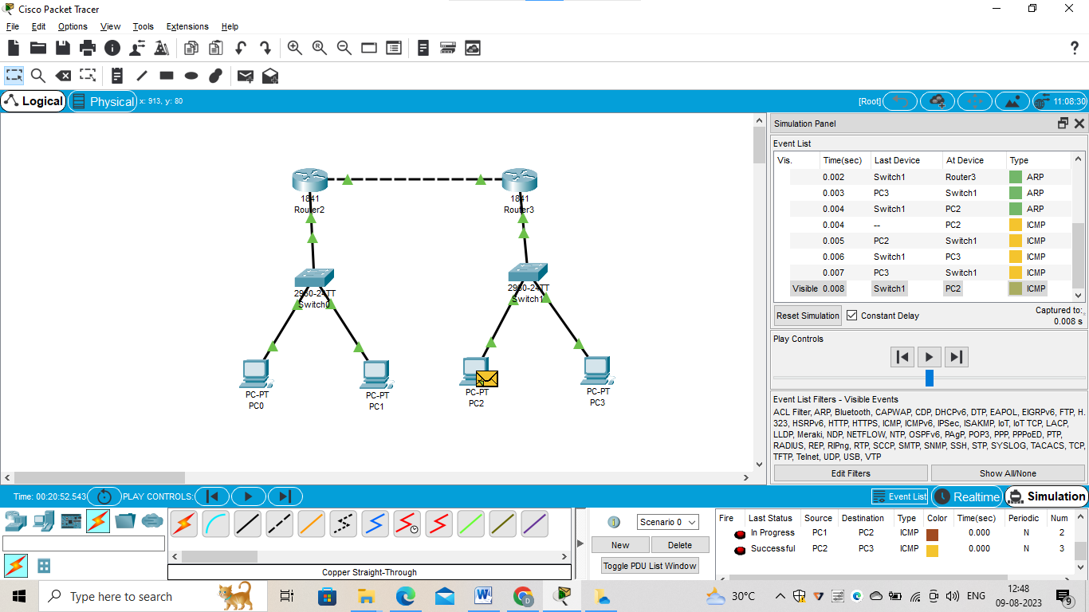

1. Dynamic Routing using Packet Tracer ( OSPF)

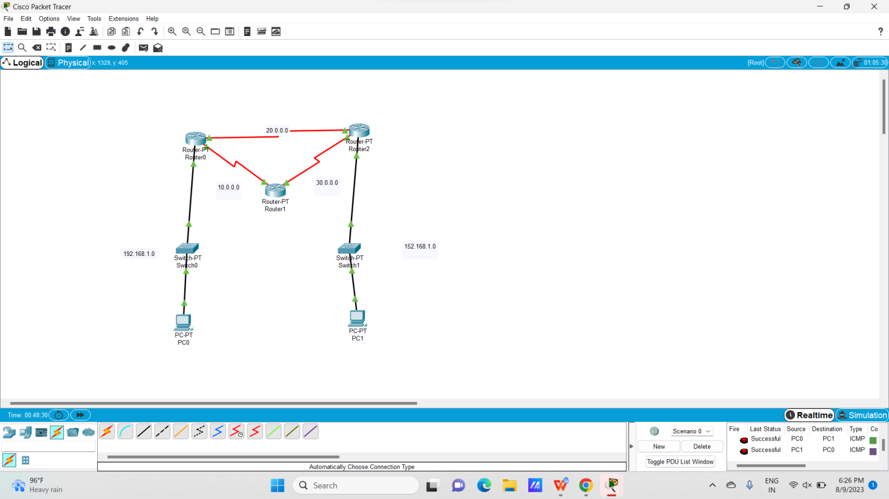

1. Subnetting – Class C Addressing

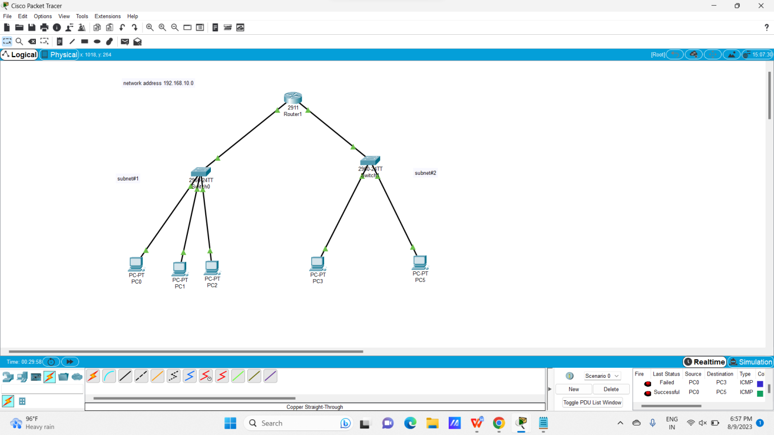

1. Functionalities of TCP, UDP

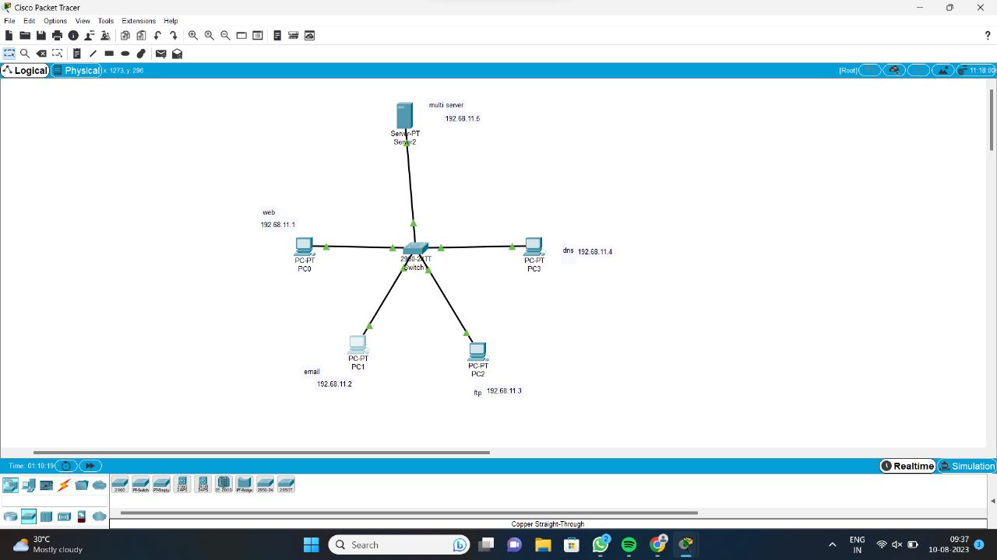

1. TCP, UDP Exploration Solution